Different Machine Learning Algorithms

- What is machine learning?

Machine learning is an emerging field of computer science that empowers computers to learn through context without being programmed. The idea of machine learning is evolved from pattern recognition and computational learning theory in artificial intelligence. The machine learning explores the study and design of different algorithms that can learn from and make predictions on data. In the present time, machine learning is employed in a range of computing tasks with good performance and this includes example applications: email filtering, detection of network intruders or malicious insiders working towards a data breach, optical character recognition (OCR), learning to rank, and computer vision etc [1].

Professor Tom M. Mitchell from Carnegie Melon University provided a widely quoted, more formal definition of the algorithms studied in the Machine Learning field: "A computer program is said to learn from experience E with respect to some class of tasks T and performance measure P if its performance at tasks in T, as measured by P, improves with experience E.” [2]

Further Links for reading:
- https://pythonprogramming.net/machine-learning-tutorial-python-introduction/
- https://www.analyticsvidhya.com/blog/2015/06/machine-learning-basics/
- https://www.tutorialspoint.com/mahout/mahout_machine_learning.htm

- Different Learning Types

Machine learning is broadly classified in three broad categories as follows:
Supervised Learning: The computer system is presented with training data and expected output. The goal is to learn a general rule and apply the knowledge gained on the test cases.

Unsupervised learning: The computer system determine itself the structure to learn from the presented data and apply the knowledge on the test cases.

Reinforcement learning: The computer system interact with the dynamic environment to achieve a particular goal and gather feedback which further improve learning.

Further Links for reading:
- http://machinelearningmastery.com/a-tour-of-machine-learning-algorithms/
- https://medium.com/towards-data-science/types-of-machine-learning-algorithms-you-should-know-953a08248861

- Common Machine Learning Algorithms

There are commonly used machine learning algorithms which can be applied to any data problems as follows:
- Linear Regression
- Logistic Regression
- Decision Tree
- Support Vector Machine
- Naïve Bayes
- K-Nearest Neighbor
- K-Means
- Random Forest
- Dimensionality Reduction Algorithm
- Gradient Boost and Adaboost
- Neural Network
- Deep Learning

For the purpose of the given assignment, the proceeding sections will highlight on Linear Regression, Logistic Regression, K Nearest Neighbor, K-means clustering, Neural Network and Deep Learning.

Further Links for reading:
- http://analyticsindiamag.com/10-machine-learning-algorithms-every-data-scientist-know/
- https://www.intechopen.com/books/new-advances-in-machine-learning/types-of-machine-learning-algorithms

- Linear Regression

Linear regression is used to estimate real values e.g. cost of houses, number of calls, total sales etc based on continuous variable(s). In this learning technique, a relationship between independent and dependent variable is established by fitting a best line. This best fit line is called regression line and represented by a linear equation Y= a *X + b in the form of equation of a line.

The overall idea of regression is to examine two things: (1) does a set of predictor variables do a good job in predicting an outcome variable? (2) Which variables in particular are significant predictors of the dependent variable?

In the above equation: Y = Dependent Variable; a= Slope; X= Independent variable and b= Intercept. The coefficients “a” and “b” are derived by means of minimizing the sum of squared difference of distance between data points and regression line.

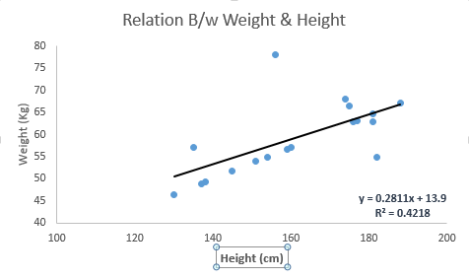
Fig 1: Linear regression representation of weight height chart [3]

As seen in the above Fig 1, the best fit line having linear equation y=0.2811x+13.9 is identified. Using this equation, new weight can be identified based on the height of a person.

The Python code is as follows:
#Import Library
from sklearn import linear_model
#Load Train and Test datasets
x_train=input_variables_values_training_datasets
y_train=target_variables_values_training_datasets
x_test=input_variables_values_test_datasets
# Create linear regression object
linear = linear_model.LinearRegression()
# Train the model using the training sets and check score
linear.fit(x_train, y_train)
linear.score(x_train, y_train)
#Equation coefficient and Intercept
print('Coefficient: \n', linear.coef_)
print('Intercept: \n', linear.intercept_)
#Predict Output
predicted= linear.predict(x_test)

Further Links for reading:
- http://onlinestatbook.com/2/regression/intro.html
- https://www.tutorialspoint.com/r/r_linear_regression.htm
- https://www.dezyre.com/data-science-in-r-programming-tutorial/linear-regression-tutorial

- Logistic Regression

Logistic regression is used to estimate discrete values which means binary values like 0/1, yes/no, true/false etc. based on given set of independent variable(s). In its simplest form, this regression predicts the probability of occurrence of an event by fitting data to a logistic function and that’s why it is called logistic regression. As it predicts the probability, its output values lies between 0 and 1.

In order to understand this, let’s consider a puzzle where there are only 2 outcome scenarios – either solve it or don’t. Now imagine, that having a wide range of puzzles / quizzes in an attempt to understand which subjects to good at. The outcome to this study would be something like this – if given a trignometry based tenth grade problem, 70% likely to solve it. On the other hand, if it is grade fifth history question, the probability of getting an answer is only 30%. This is what Logistic Regression provides you.

Coming to the math, the log odds of the outcome is modeled as a linear combination of the predictor variables.
odds= p/ (1-p) = probability of event occurrence / probability of not event occurrence
ln(odds) = ln(p/(1-p))
logistic(p) = ln(p/(1-p)) = b0+b1X1+b2X2+b3X3....+bkXk

In the above equation, p is the probability of presence of the characteristic of interest. It chooses parameters that maximize the likelihood of observing the sample values rather than that minimize the sum of squared errors.

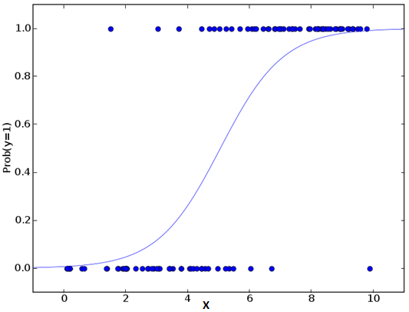
Fig 2: Logistic regression representation [3]

The Python code is as follows:
#Import Library
from sklearn.linear_model import LogisticRegression
#Assumed you have, X (predictor) and Y (target) for training data set and x_test(predictor) of test_dataset
# Create logistic regression object
model = LogisticRegression()
# Train the model using the training sets and check score
model.fit(X, y)
model.score(X, y)
#Equation coefficient and Intercept
print('Coefficient: \n', model.coef_)
print('Intercept: \n', model.intercept_)
#Predict Output
predicted= model.predict(x_test)

Further Links for reading:
- https://web.stanford.edu/class/psych252/tutorials/Tutorial_LogisticRegression.html
- https://www.dezyre.com/data-science-in-r-programming-tutorial/logistic-regression-tutorial
- https://www.hackerearth.com/practice/machine-learning/machine-learning-algorithms/logistic-regression-analysis-r/tutorial/

- k-Nearest Neighbors

In pattern recognition domain, the k-nearest neighbors algorithm (k-NN) is a non-parametric method used for classification and regression. It can be used for both classification and regression problems. It is more widely used in classification problems in the industry. In the simplest form, K nearest neighbors stores all available cases and classifies new cases by a majority vote of its k neighbors. The case being assigned to the class is most common amongst its K nearest neighbors measured by a distance function. In both cases, the input consists of the k closest training examples in the feature space.

The similarity measure is achieved through distance calculation. These distance functions can be Euclidean, Manhattan, Minkowski and Hamming distance. First three functions are used for continuous function and fourth one (Hamming) for categorical variables. If K = 1, then the case is simply assigned to the class of its nearest neighbor. At times, choosing K turns out to be a challenge while performing KNN modeling.

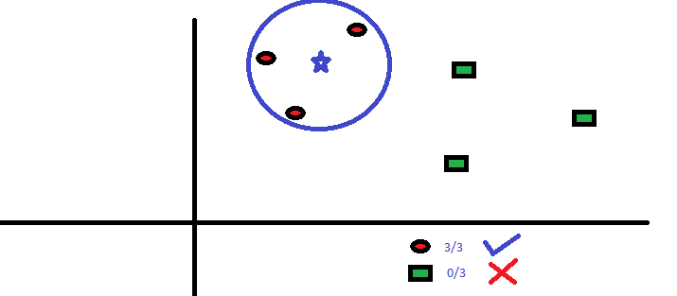

Fig 3: k-nearest neighbors representation [3]

The Python code is as follows:
#Import Library
from sklearn.neighbors import KNeighborsClassifier
#Assumed you have, X (predictor) and Y (target) for training data set and x_test(predictor) of test_dataset
# Create KNeighbors classifier object model
KNeighborsClassifier(n_neighbors=6) # default value for n_neighbors is 5
# Train the model using the training sets and check score
model.fit(X, y)
#Predict Output
predicted= model.predict(x_test)

Further Links for reading:
a. https://saravananthirumuruganathan.wordpress.com/2010/05/17/a-detailed-introduction-to-k-nearest-neighbor-knn-algorithm?
b. http://people.revoledu.com/kardi/tutorial/KNN/
c. https://www.dataquest.io/blog/k-nearest-neighbors-in-python/

- k-Means Clustering

k-Means Clustering is a type of unsupervised learning algorithm which solves the clustering problem. It follows simple procedure and easy way to classify a given data set through a certain number of clusters which is assumed k clusters. Data points inside a cluster are homogeneous and heterogeneous to peer groups.

How cluster is formed:
- K-means picks k number of points for each cluster known as centroids.
- Each data point forms a cluster with the closest centroids i.e. k clusters.
- Finds the centroid of each cluster based on existing cluster members. Here we have new centroids.
- As we have new centroids, repeat step 2 and 3. Find the closest distance for each data point from new centroids and get associated with new k-clusters. Repeat this process until convergence occurs i.e. centroids does not change.

How to determine value of K:
In K-means, we have clusters and each cluster has its own centroid. Sum of square of difference between centroid and the data points within a cluster constitutes within sum of square value for that cluster. Also, when the sum of square values for all the clusters are added, it becomes total within sum of square value for the cluster solution.

We know that as the number of cluster increases, this value keeps on decreasing but if you plot the result you may see that the sum of squared distance decreases sharply up to some value of k, and then much more slowly after that. Here, we can find the optimum number of cluster.

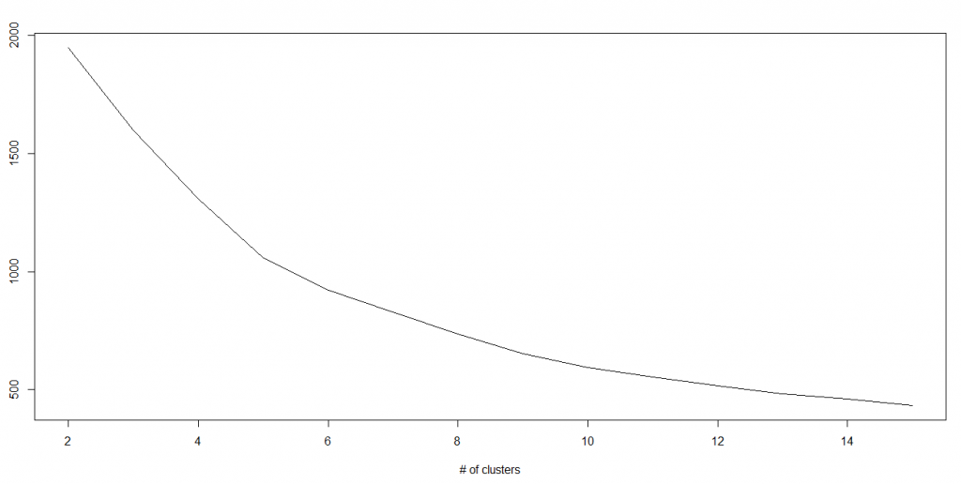

Fig 4: k-means clustering representation [3]

The Python code is as follows:
#Import Library
from sklearn.cluster import KMeans
#Assumed you have, X (attributes) for training data set and x_test(attributes) of test_dataset
# Create KNeighbors classifier object model
k_means = KMeans(n_clusters=3, random_state=0)
# Train the model using the training sets and check score
model.fit(X)
#Predict Output
predicted= model.predict(x_test)

Further Links for reading:
a. https://www.datascience.com/blog/introduction-to-k-means-clustering-algorithm-learn-data-science-tutorials
b. http://people.revoledu.com/kardi/tutorial/kMean/
c. http://mnemstudio.org/clustering-k-means-example-1.htm

- Neural Network

Neural Network, also known as Artificial Neural network (ANN), is an information processing domain inspired by the way our biological nervous systems, such as the brain, process information. The key component of this concept is the novel structure called “neuron” of the information processing system. It is composed of a large number of highly interconnected processing elements i.e. neurones working in unison to solve specific problems. Neural network is configured for a specific application, such as pattern recognition or data classification, through a learning process. Learning in biological systems involves adjustments to the synaptic connections that exist between the neurones.

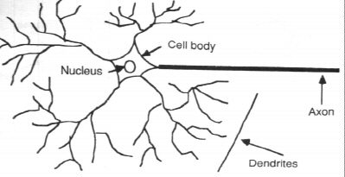

Fig 5: Components of a neuron [source: Internet]

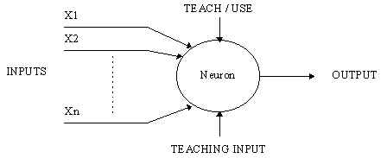

Fig 6: A simple neuron [source: Internet]

As shown in the Fig 5 and Fig 6, an artificial neuron is like a device with many inputs and one output. The neuron has two modes of operation; the training mode and the testing mode. In the training mode, the neuron can be trained to fire (or not), for particular input patterns. In the testing mode, when a taught input pattern is detected at the input, its associated output becomes the current output. If the input pattern does not belong in the taught list of input patterns, the firing rule is used to determine whether to fire or not.

The Python code is as follows:
from numpy import exp, array, random, dot
training_set_inputs = array([[0, 0, 1], [1, 1, 1], [1, 0, 1], [0, 1, 1]])
training_set_outputs = array([[0, 1, 1, 0]]).T
random.seed(1)
synaptic_weights = 2 * random.random((3, 1)) - 1
for iteration in xrange(10000):
output = 1 / (1 + exp(-(dot(training_set_inputs, synaptic_weights))))
synaptic_weights += dot(training_set_inputs.T, (training_set_outputs - output) * output * (1 - output))
print 1 / (1 + exp(-(dot(array([1, 0, 0]), synaptic_weights))))

Further Links for reading:
a. https://www.tutorialspoint.com/artificial_intelligence/
artificial_intelligence_neural_networks.htm
b. http://adventuresinmachinelearning.com/neural-networks-tutorial/
c. http://www.wildml.com/2015/09/recurrent-neural-networks-tutorial-part-1-introduction-to-rnns/

- Deep Learning

Deep learning, which is also known as deep structured learning or hierarchical learning, is the application of artificial neural networks (ANNs) to learning tasks that contain more than one hidden layer. It is part of a broader family of machine learning methods based on learning data representations, as opposed to task-specific algorithms. Besides, learning can be supervised, partially supervised or unsupervised [4][5][6][7].

There are some representations which are loosely based on interpretation of information processing and communication patterns in a biological nervous system, such as neural coding that attempts to define a relationship between various stimuli and associated neuronal responses in the brain. Research attempts to create efficient systems to learn these representations from large-scale, unlabeled data sets. The deep learning architectures such as deep neural networks, deep belief networks and recurrent neural networks have been applied to fields including computer vision, speech recognition, natural language processing, audio recognition, social network filtering, machine translation and bioinformatics etc.

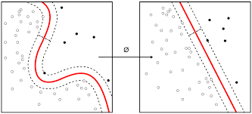
Fig 7: Representation of deep learning [source: Internet]

Further Links for reading:
a. https://deeplearning4j.org/tutorials
b. https://www.toptal.com/machine-learning/an-introduction-to-deep-learning-from-perceptrons-to-deep-networks
c. https://www.datacamp.com/community/tutorials/deep-learning-python

- Conclusion
In this assignment, basic concept behind selected machine learning algorithm is described with further link to different learning resources and tutorials. This is expected to develop further in this very interesting subject areas.
1. https://en.wikipedia.org/wiki/Machine_learning last accessed on 9 August 2017
2. https://en.wikipedia.org/wiki/Tom_M._Mitchell last accessed on 9 August 2017
3. https://www.analyticsvidhya.com/blog/2015/08/common-machine-learning-algorithms/ last accessed on 9 August 2017
4. Bengio, Y.; Courville, A.; Vincent, P. (2013). "Representation Learning: A Review and New Perspectives". IEEE Transactions on Pattern Analysis and Machine Intelligence. 35 (8): 1798–1828. arXiv:1206.5538 Freely accessible. doi:10.1109/tpami.2013.50.
5. Schmidhuber, J. (2015). "Deep Learning in Neural Networks: An Overview". Neural Networks. 61: 85–117. PMID 25462637. arXiv:1404.7828 Freely accessible. doi:10.1016/j.neunet.2014.09.003.
6. Bengio, Yoshua; LeCun, Yann; Hinton, Geoffrey (2015). "Deep Learning". Nature. 521: 436–444. doi:10.1038/nature14539.
7. Jürgen Schmidhuber (2015). Deep Learning. Scholarpedia, 10(11):32832. Online

